Setting up CPRS for independant access of Custom Control libraries

As the CPRS team expands into more and more libraries it has become evident that a simpler way of managing these controls is needed. This document will outline a streamlined method of installing the components without the need for all the extraneous path definitions we have used in the past. All component source is now stored under a Delphi specific (XE3, XE5, XE8, etc.) stream in Jazz so that developers can run multiple versions of Delphi with separate controls for each version. Before beginning find a directory outside of the Jazz Workspaces to place the compiled packages into. This needs to be outside of the Jazz Workspaces because the new setup uses the compiled units instead of the traditional source code paths where everything is constantly re-compiled into the CPRS project. If the developer wishes to use the same directory as was defined before with the CPRS environment variable that is fine so long as that variable references a directory that is *outside* of all Jazz Workspaces. With this setup in place all copies of CPRS compiled or built will be using the same versions of the Run Time and Design Time libraries, including the build machine. Once this is completed, code will be added to CPRSChart that will check the versions of the components, further guaranteeing that the final product we release is exactly what we think it is.

To begin we need to uninstall all existing components.

Step 1: Start Delphi but *do not open any projects*.

Step 2: In the menus select Component | Install Packages …

Step 3: The following dialog will display (package names may be different but similar):

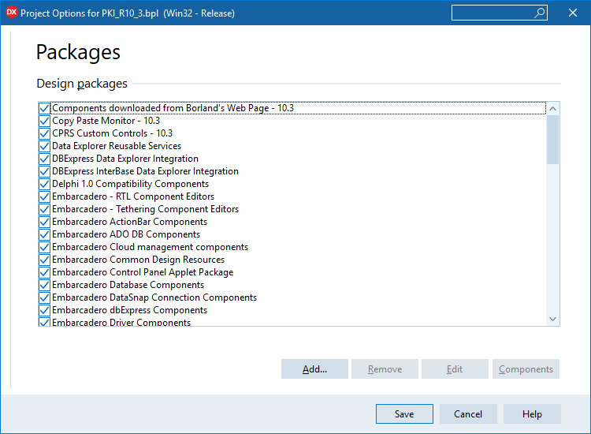

Step 4: Select the following packages and click on Remove to take them out of your configuration. Be sure to ask if you find packages that don't look like standard Delphi packages but may need to be cleared out anyway.

1. Copy Paste Monitor – 10.3
2. Components downloaded from Borland's Web Page
3. CPRS Custom Controls – 10.3
4. VA Section 508 Accessibility – 10.3
5. VistA RPC Broker – 10.3

Step 5: Close this dialog.

Now we need to verify the paths and environment variables. Under the menus select Tools | Options … and the following dialog will be presented. Select Environment Variables.

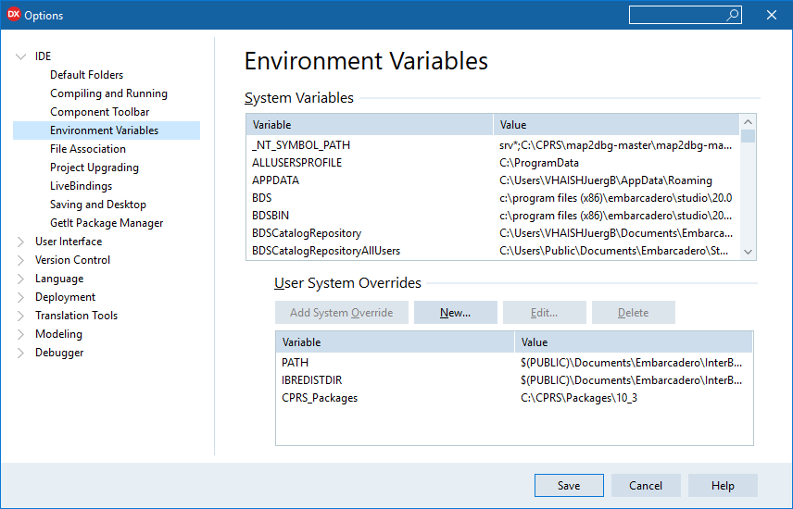

In the environment variables delete any that are specific to the CPRS project (i.e. Broker, PKI, AVLogger etc.). Do not remove any that are sepcific to BDS settings. The example above shows a the new CPRS_Packages variable pointing to the directory that we described at the beginning of this document. Your directory may be different. Again, this is NOT to be the Jazz Sandbox directories. Also notice that the last sub-directory is 10_3. This is because you will be compiling the components for each version of Delphi, and we do not want compiled libraries in the CPRS_PACKAGES_v1_3_D10_3 stream.

***You must ensure that the last subdirectory in the packages target folder (C:\Data\CPRS\Packages\XE8 above) is different for each version of Delphi you have installed on the computer. Do NOT attempt to use C:\Data\CPRS\Packages\10_2 for both Delphi 10.2.x and Delphi 10.3.***

Now we need to select the Library settings as shown here.

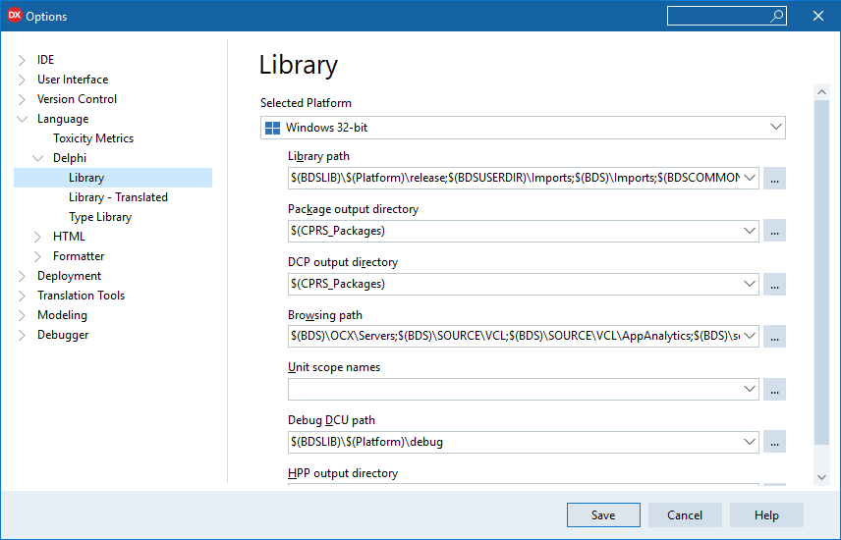

Notice that the Package output directory and DCP output directory are the same. This is where the custom controls will be placed to be accessed by the IDE. Open up the Library path with the […] button.

Previously we setup paths for each component package as shown here.

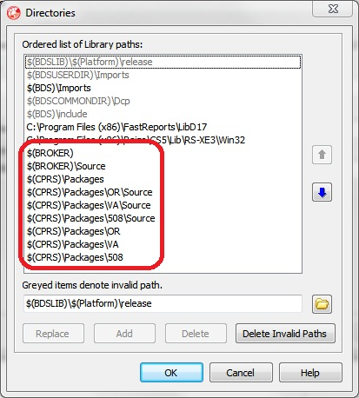

You may also have a patch for the AVLogger as well. We want to clean these up by selecting them in the list and pressing Delete. Do *not* press the Delete Invalid Paths button.

Now we will add a new two new entries to the bottom of the list for

$(CPRS_Packages)

and

$(CPRS_Packages)\Resource

You should now have a list with the two paths at the bottom as shown:

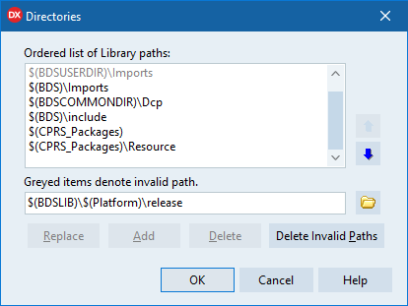

It is important to *ignore* any invalid paths at this time because we haven't moved the new compiled libraries into the directory.

Finally, we need to change the package output directory and DCP output directory to $(CPRS_Packages).

Shutdown and restart Delphi to let it sort out the new directories. Just agree with what it wants to do if it pops up a dialog about paths.

If this is not a new install, it is a good idea to get a copy of the Scrubbing Old Delphi Components From My Workstation document and do a thorough cleaning of any rogue libraries that may have been created in the past. These libraries are known for cropping up at the wrong time in the wrong place of your path variable and causing weird errors and issues.

Open Jazz and get the latest version of CPRS_Packages:

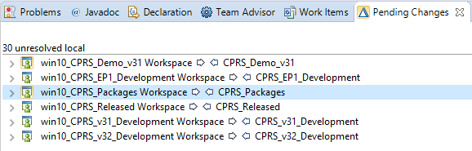

The arrows between CPRS_Packages and your local repository workspace should both be clear (see above).

In Delphi, pull down the “File” menu, and select “Open Project…”

In the resulting dialog, browse until you see the packages .groupproj file.

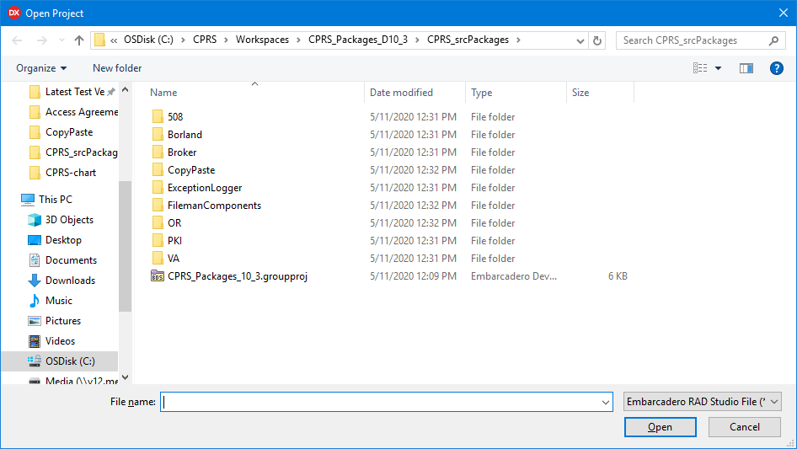

Double-click on the CPRS_Packages_10_3.groupproj file. This will open a project group containing all of the project files:

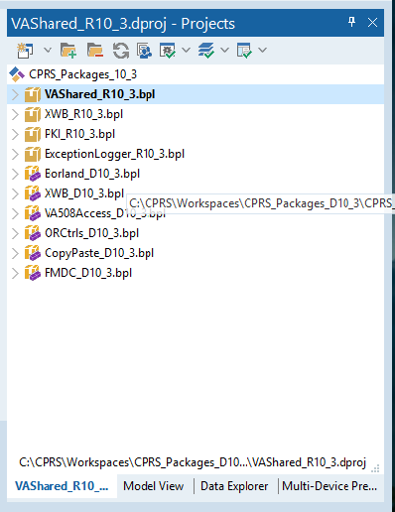

Right click on the “CPRS_Packages_10_2” item at the top of the project manager, and select “Build All” from the popup menu:

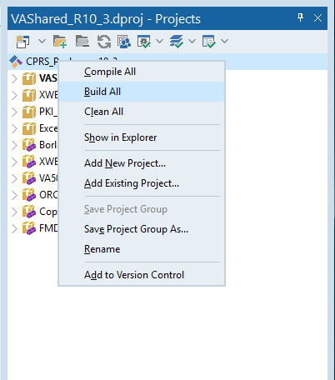

This will recompile all of the CPRS packages. Once this build is done, you will need to install the compile-time packages. Click on “XWB_D10_3.bpl”, shift click on “FMDC_D10_3.bpl” and select “Install” from the popup menu:

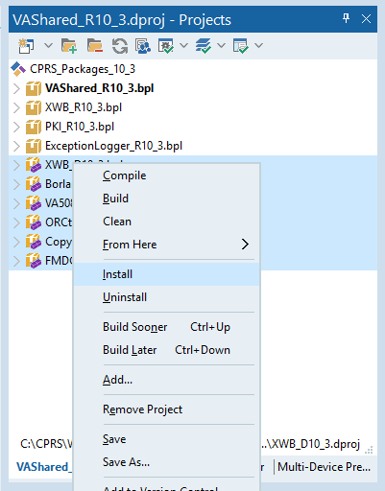

You have now completed the installation process for the CPRS packages.

***OPTIONAL –* Set up Browsing Paths**

If you wish to be able to browse to the component source by clicking classes, the easiest way to do this is to add a second environment variable, CPRS_Packages_Source.

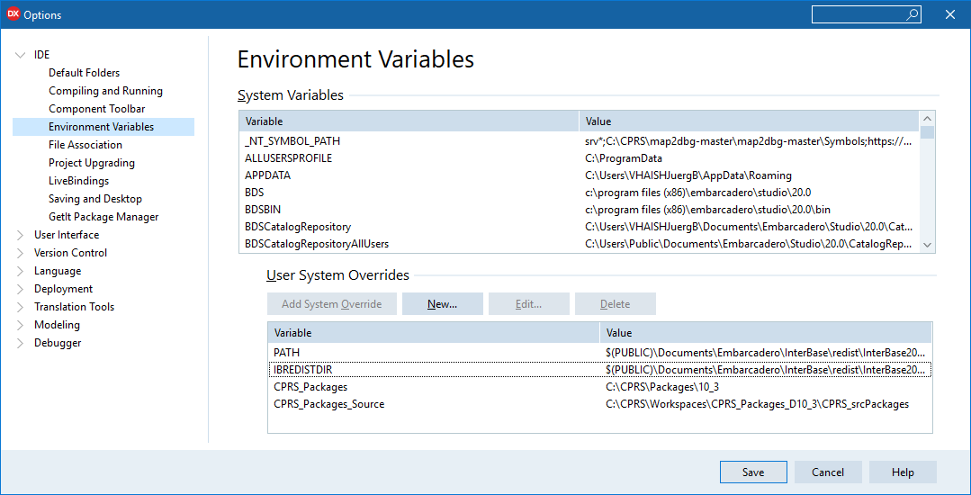

CPRS_Packages_Source needs to be set to the root directory of your source path. Then, open the Language -> Delphi -> Library tree again:

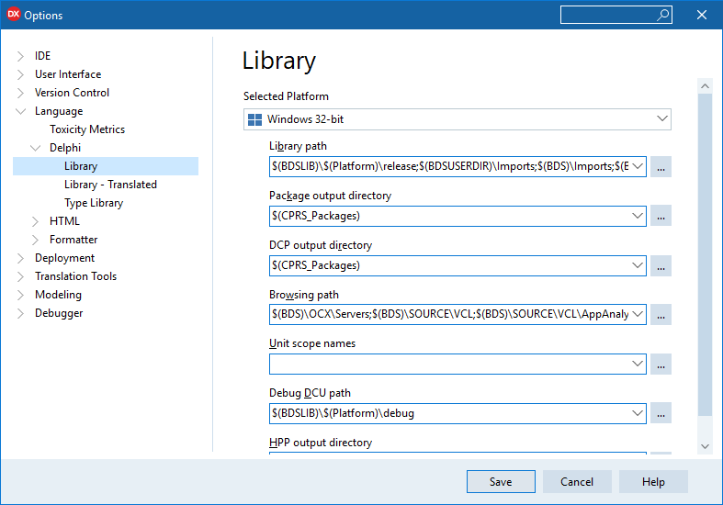

And select the ellipsis button next to the “Browsing path” edit box.

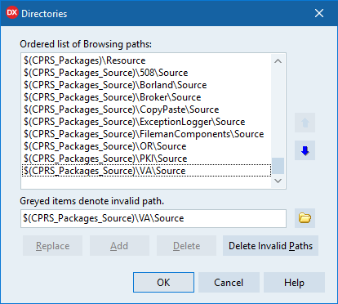

Add the directories to match the above dialog, and you will be able to browse to the component source code at need.

***BE AWARE OF THESE VARIABLES!*** It is easy to confuse both yourself and Delphi if you set your browsing path to a different directory than the directory that contains your package source. It is advisable that you only have one packages source and library directory for each version of Delphi you have installed. However, if you MUST have multiple copies of the package source installed, it is advisable that you remove the CPRS_Packages_Source environment variable temporarily to prevent confusion.